**Upgrade frontend application to Nginx web server**

1. Install Nginx web host on the targeted server.  
     
   a. Go to web browser and search for Nginx, Navigate to Nginx official site.  
     
   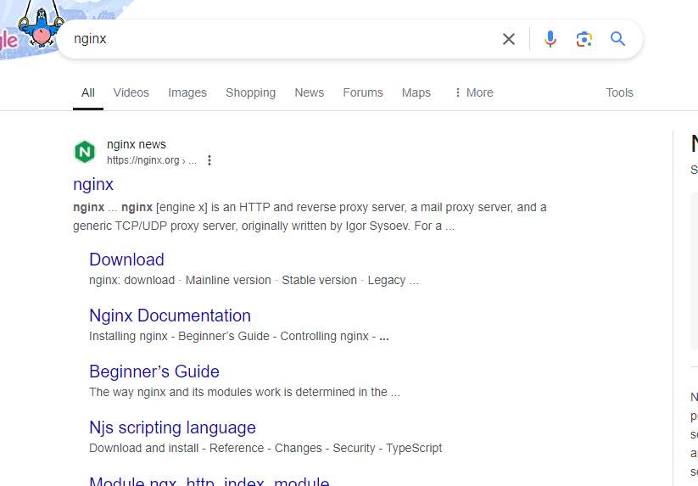  
     
   b. Download stable version.  
     
   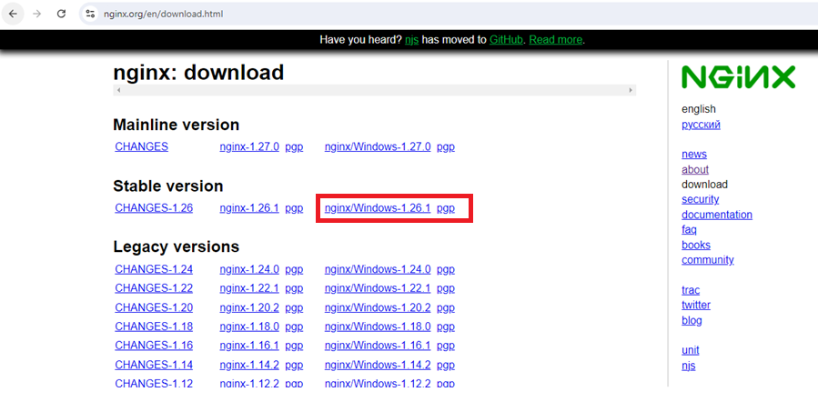

c. Nginx setup zip file will be downloaded. Extract to targeted location.

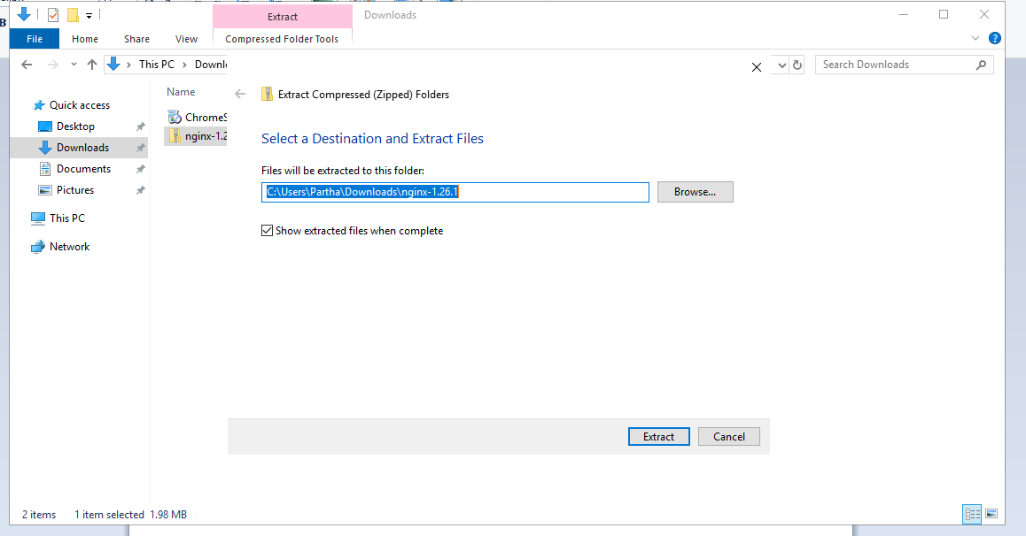

1. Start Nginx server and verify running.
2. Go to command prompt and navigate to nginx setup path and run command   
     
   >> start nginx

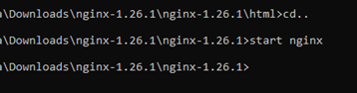

1. Go to browser and check nginx  
   browse for localhost  
     
   By default nginx service run on port 80, you will see out put as below.  
     
   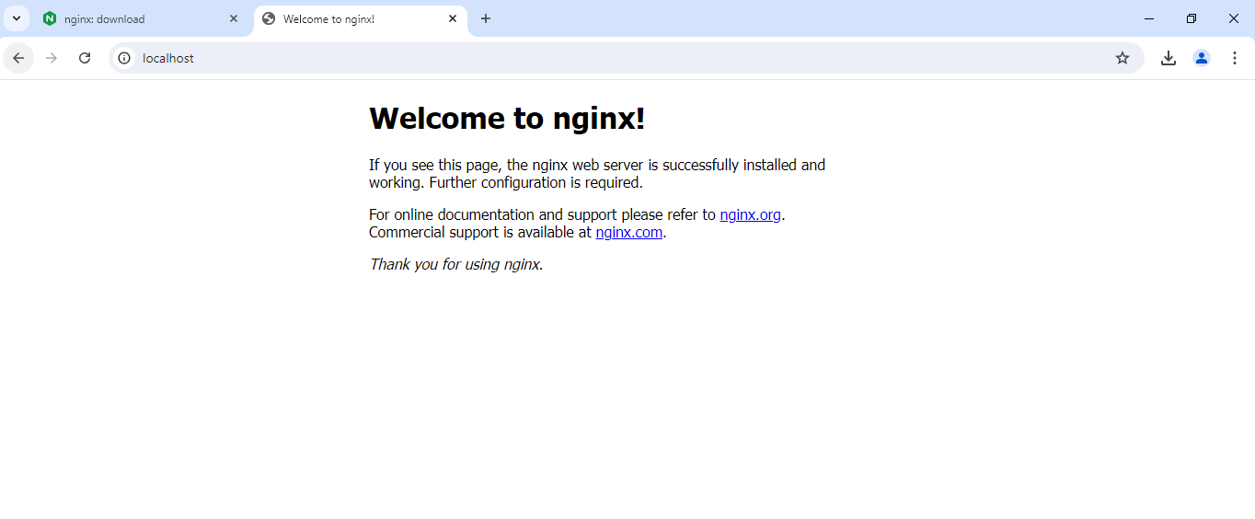
2. Setup your Application on Nginx.  
     
   a. Go to nginx setup folder and find the location “html”. Replace default code with your actual application files.  
     
   A screenshot of a computer

   Description automatically generated

b. go to browser and refresh the nginx tab, now you will see your application.  
  
browse for localhost:80

1. Disable application port on local environment.  
     
   a. Go to windows firewall on server and navigate to inbound rule select the rule configured for application and disable it.  
     
   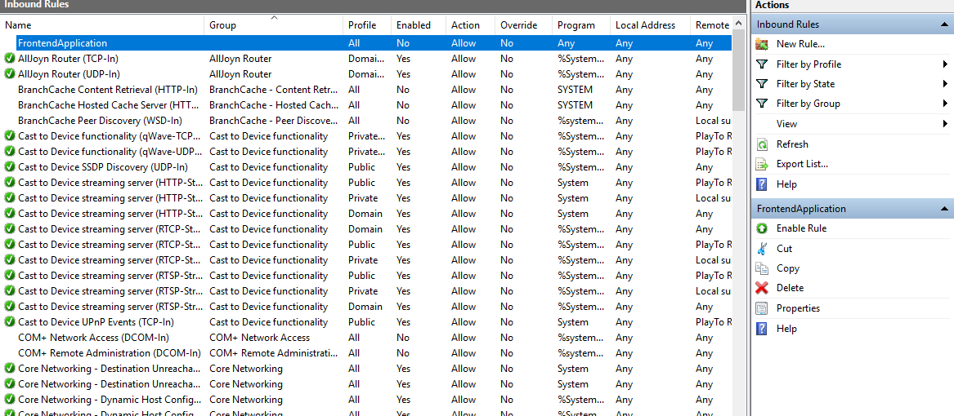
2. Change the Nginx port to your desire port for application.  
     
   a. Go to Nginx folder and go to “nginx.conf”   
   b. Replace your actual port with default port 80 under server-> listen.  
     
   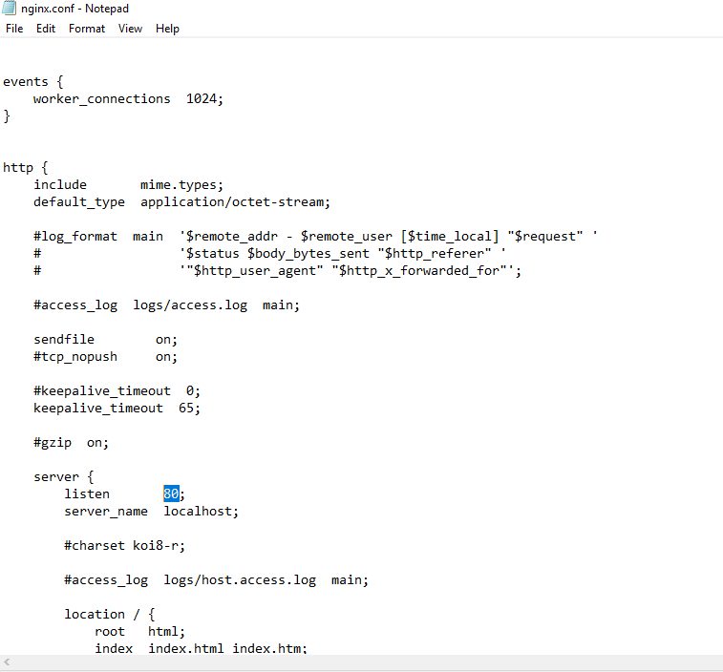
3. Restart the nginx service and check nginx configuration status.  
     
   Navigate to command prompt and run below commands.  
     
   >>



Browse >>localhost:given_port  
you will get the application.

1. Set the Nginx service as automatic so that whenever the server is up the application should run automatically. Server reboot will not affect nginx service to stop.  
     
   a. Download NSSM from it’s official site and download Latest release version.  
     
   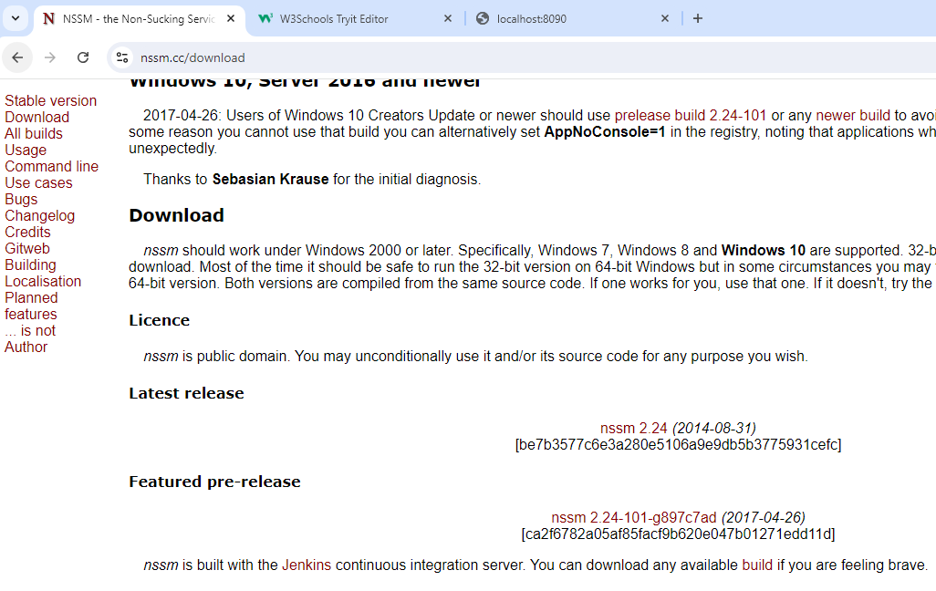
2. Unzip download setup file and open it with CMD.  
     
   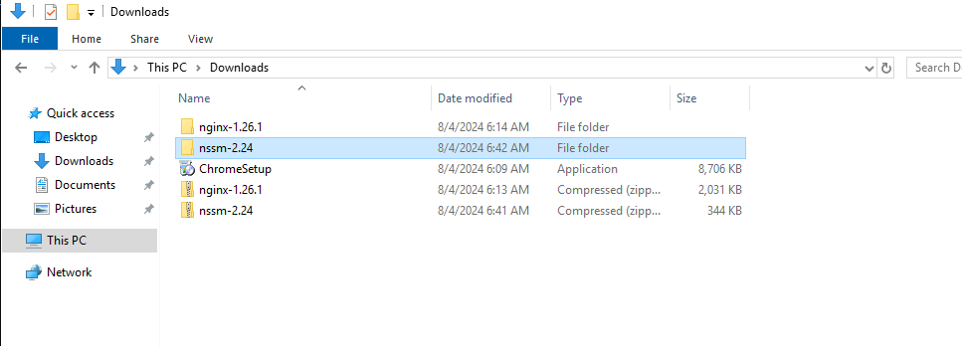
3. Navigate to win64 folder as shown below.  
     
   
4. Run command >>’ nssm install nginx’ and set the path and directory as nginx setup “nginx.exe” file.  
     
     
     
   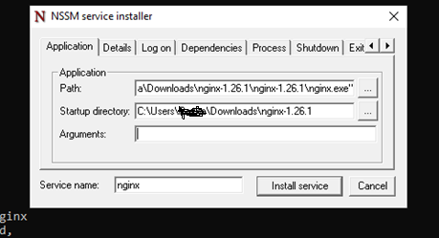
5. In details verify the service is set as automatic.  
     
   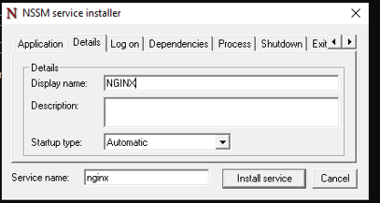
6. Nginx service will install successfully.  
     
   A screenshot of a computer error

   Description automatically generated
7. Start the nginx service.  
   >>nssm start nginx  
     
   
8. Go to services and verify the service state and properties.  
   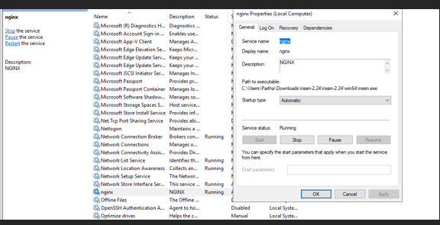
9. Add inbound rule to server NSG to access the application over internet.  
     
   a. Go to server -> navigate to NGS and add the desire port to inbound rule.  
     
   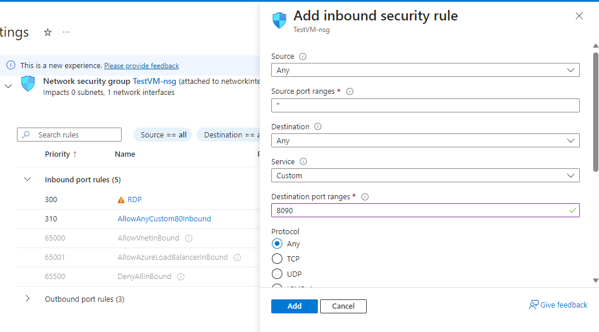
10. Verify the port added successfully.  
      
    A screenshot of a computer

    Description automatically generated  
      
      
    Browse the application on internet by **server_publicIP:given_port**